# Koala Corporation

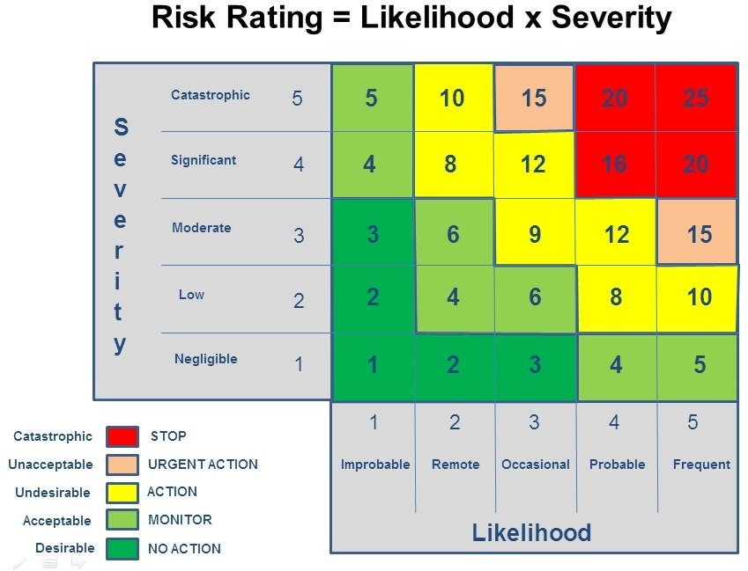**Risk Register**

## Risk management

The risk assessment process will be used by the management team to ensure risk control methods are included in all organisational planning, management of operations and governance.

## Definitions

Definitions are based on the Australian and New Zealand Risk Management Standard AS/NZS 4360:2004.

## Risk

The chance of something happening which will have an impact upon objectives. It is measured in terms of *consequence* and *likelihood.*

## Likelihood

A qualitative description or synonym for probability or frequency.

## Consequence

The outcome of an event or situation, expressed qualitatively or quantitatively, being a loss, injury, disadvantage or gain. There may be a range of possible outcomes associated with an event.

## Risk assessment

The overall process of risk analysis and risk evaluation.

## Risk treatment/control methods

Selection and implementation of appropriate options for dealing with risk. Conceptually, treatment options will involve one or a combination of the following five strategies

* Avoid the risk
* Reduce the likelihood of occurrence
* Reduce the consequences of occurrence
* Transfer the risk
* Retain/accept the risk.

## Risk management process

The systematic application of management policies, procedures and practices to the tasks of establishing the context, identifying, analysing, evaluating, treating, monitoring and communicating risk.

**Risk assessment legend**

# Koala Corporation

|  |  |  |  |  |  |
| --- | --- | --- | --- | --- | --- |
| **Area** | **Risk** | **Severity** | **Likelihood** | **Risk Rating** | **Treatment/control methods** |
| Area 1: |  |  |  |  |  |
| Area 2: |  |  |  |  |  |
| Area 3: |  |  |  |  |  |
| Area 4: |  |  |  |  |  |
| Area 5: |  |  |  |  |  |
| Area 6: |  |  |  |  |  |
| Area 7: |  |  |  |  |  |
| Area 8: |  |  |  |  |  |
| Area 9: |  |  |  |  |  |
| Area 10: |  |  |  |  |  |